Create Jar packages to
communicate with Keyloak

- MyRemoteUserStorageProvider

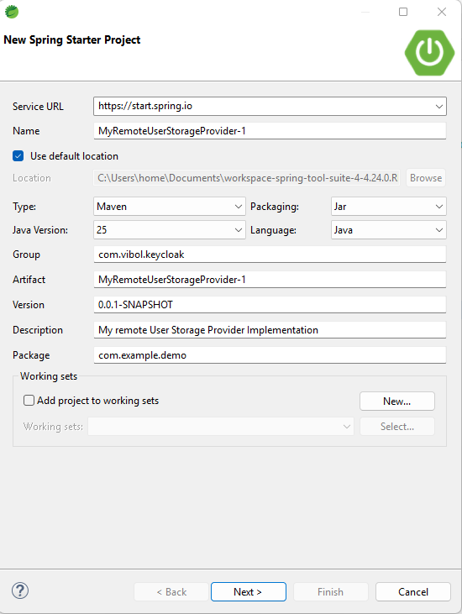
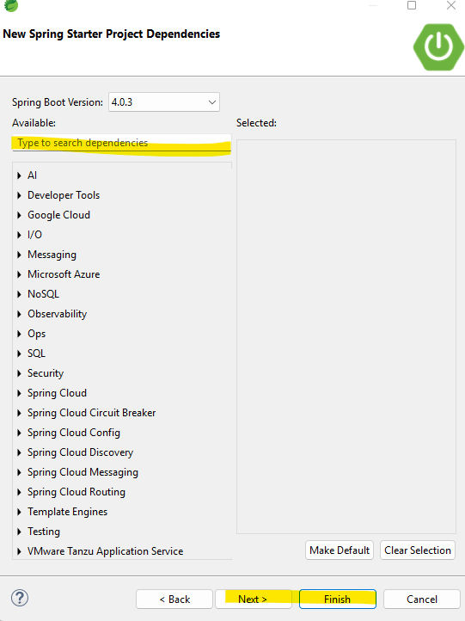

In Spring boot create from Spring tool suit it does not have Keyloak service!
- Go to website: https://mvnrepository.com/

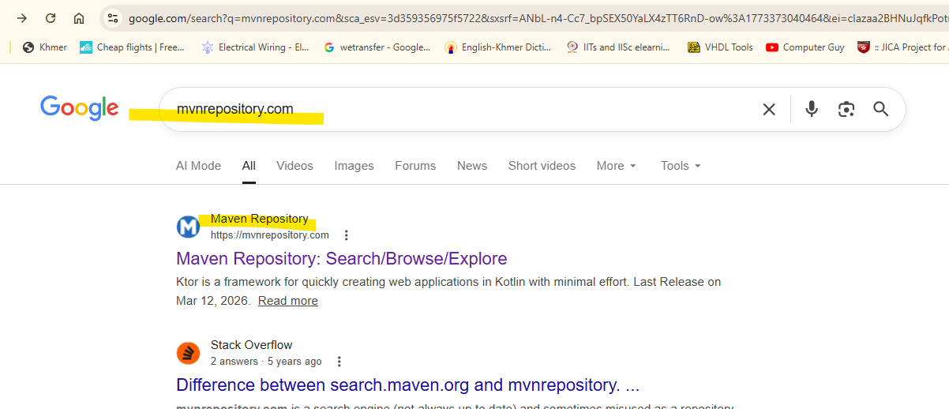

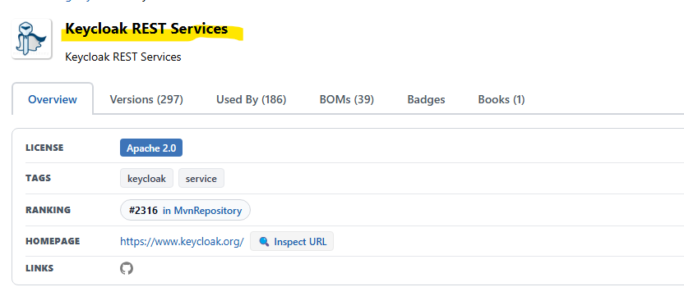

- Dependany keep only the keyloak service because we convert it to jar package. And remove the run from spring boot!

<?xml version="1.0" encoding="UTF-8"?>
<project xmlns="http://maven.apache.org/POM/4.0.0"
xmlns:xsi="http://www.w3.org/2001/XMLSchema-instance"
xsi:schemaLocation="http://maven.apache.org/POM/4.0.0 https://maven.apache.org/xsd/maven-4.0.0.xsd">
<modelVersion>4.0.0</modelVersion>

<groupId>com.vibol.keycloak</groupId>
<artifactId>MyRemoteUserStorageProvider</artifactId>
<version>0.0.1-SNAPSHOT</version>
<name>MyRemoteUserStorageProvider</name>
<description>My remote User Storage Provider Implementation</description>
<url />
<licenses>
<license />
</licenses>
<developers>
<developer />
</developers>
<scm>
<connection />
<developerConnection />
<tag />
<url />
</scm>
<properties>
<java.version>25</java.version>
</properties>
<dependencies>

<!-- Source:
https://mvnrepository.com/artifact/org.keycloak/keycloak-services -->
<dependency>
<groupId>org.keycloak</groupId>
<artifactId>keycloak-services</artifactId>
<version>26.5.5</version>
<scope>compile</scope>
</dependency>

</dependencies>

<build>

</build>

</project>

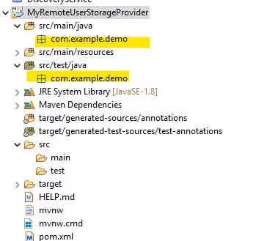

- Create implementation from keyloak
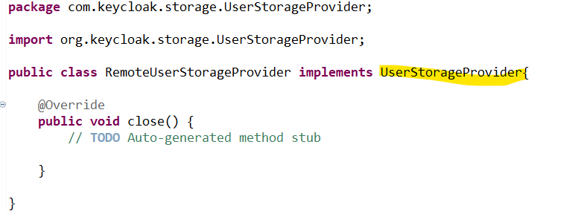

  - UserStorageProvider : វាជា callback សម្រាប់ធ្វើការ លុបទិន្នន័យបន្ទាប់ពីKeyloak remove user.

Callback when a realm is removed. Implement this if, for example, you want to do some * cleanup in your user storage when a realm is removed

2.2 :To lookup user detail from remote storage: we implemented
ដើម្បីធ្វើការចូលទៅមើលក្នុង external user storage យើងត្រូវធ្វើការ implement from: UserLookupProvider
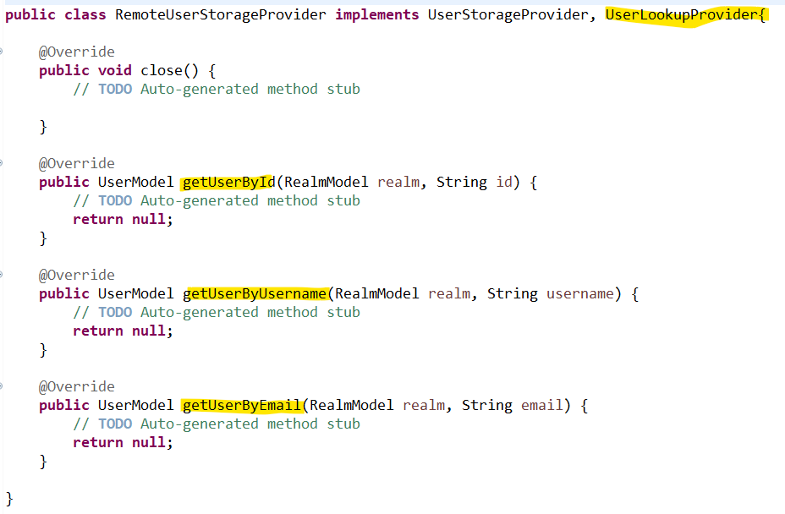

  - to validate the user credentials សម្រាប់ធ្វើការផ្ទាង់ផ្ទាត់ User login ចូលមកនឹងមាន User and Password ត្រឹមត្រូវជាមួយ external storage ឬអត់
(CredentialInputValidator)
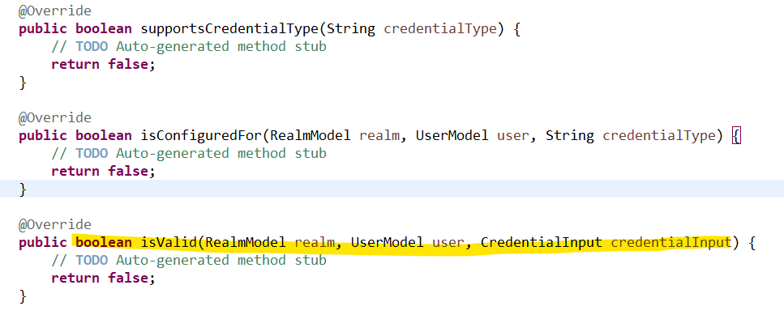

In the isValid : បើត្រឹមត្រូវវា នឹង return true.

- Create instance of user provider បង្កើត object ដែលធ្វើការចូលមកម្តង់មួយៗដើម្បីធ្វើការ access the external in the keyloak

- Create a new Java class that will be called Remote User Storage Provider Factory, and it will be used to create an instance of the remote user storage provider class that we have created in previous video lesson.
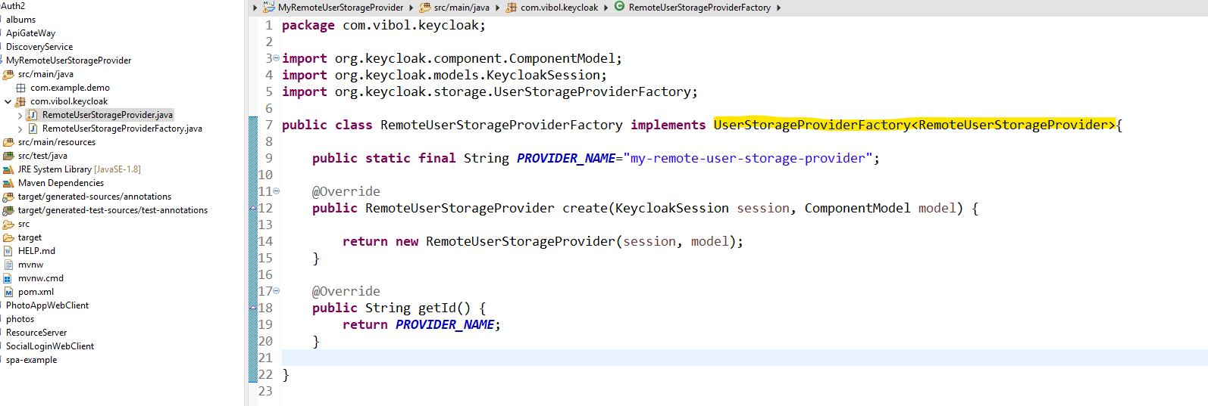

- បង្កើត Class : RemoteUserStorageProviderFactory សម្រាប់ធ្វើការ រក្សា Object មួយៗដែលបានធ្វើការ Request Autentication មកនឹង
- UserStorageProviderFactory<RemoteUserStorageProvider> ធ្វើការបង្កើត UserStorage ដែលមាន Type វាជា RemoteUserStorageProvider
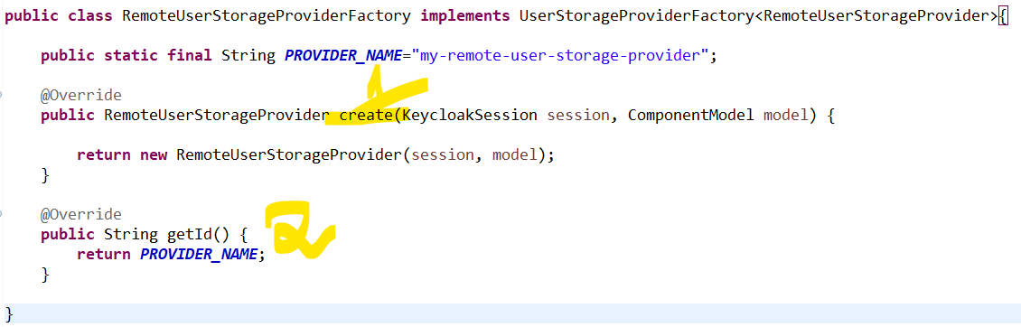

- RemoteUserStorageProvider create បង្កើត object
- String getId() : message to the keyload
In the class: RemoteUserStorageProvider We create contrucator that have two files
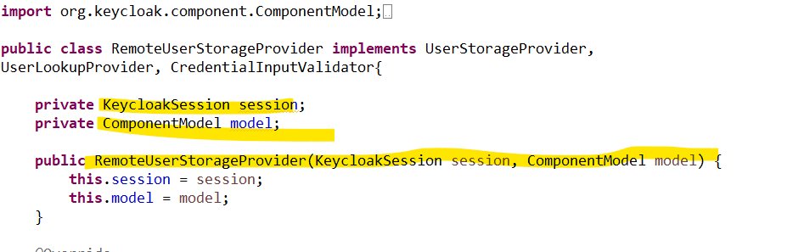

- Fetching user detail from remote storage
